Foundational aspects of data science
Group project
21.12.2022
Artem Khomytskyi (20221686)
Antony Yonan (20221003)
David Azarov (20221688)
Timofii Kuzmenko (20221690)

EXECUTIVE SUMMARY
For 3 months our team of 4 people worked hard on the project for Health and Beauty Pharmacy, and we are ready to present the best solution for their problem. The problem of the company was to understand which clients we need to contact to propose a new service of nutrition appointment. Using all our knowledge, resources and functions of the SAS® OnDemand program we suggest sending proposals to people which are presented in decision tree 3 to increase the company's profit significantly. For getting more information on how we came up with this idea please read all this document which we present to you.
INTRODUCTION
Over the course of a month, the team of group D processed the Train dataset using the SAS® OnDemand program, as a result of which we suggested which clients should be contacted in order to maximize the cost benefits of The Health and Beauty Pharmacy’s – company that sells medicine for over 7 year and wants to understand, who they need to contact to inform about new services

METHODOLOGY
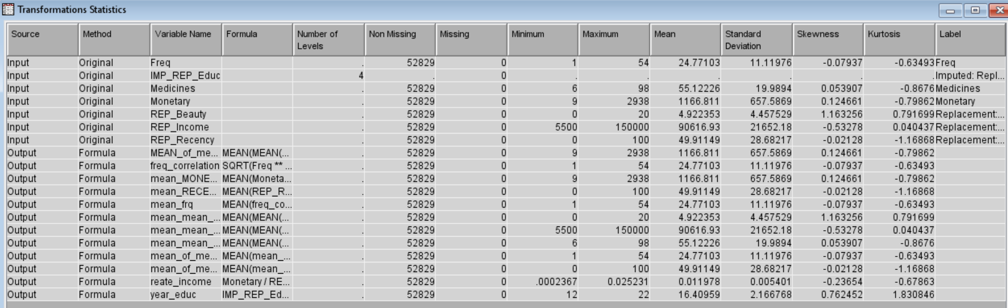
Starting with choosing nutritionpoint we have filtered and replaced impute variables in ‘’ Transform Variables’’, then we created mean of means of some variables. Mean of means of variable gave us one single value that can help summarize a lot of data so using it we made mean of the means of 3 variables (the model comparison). We chose neural network 3 as best model and after that we made more than 3 variables around 6 variables, we found neural network k2 as best model
After we made Transform Variables and run it, we made 5 type of clustering data:
1st – we implemented automatic methods
2nd – we changed to user specify with maximum cluster 2
3rd - we changed to user specify with maximum cluster 3
4th - we change to user specify with maximum cluster 4
5th - we change to user specify with maximum cluster 5
We set a relationship between clusters according to RSQ and choose cluster user to specify max cluster = 3. Also, we can set max to 4. These 2 clusters are best to get result
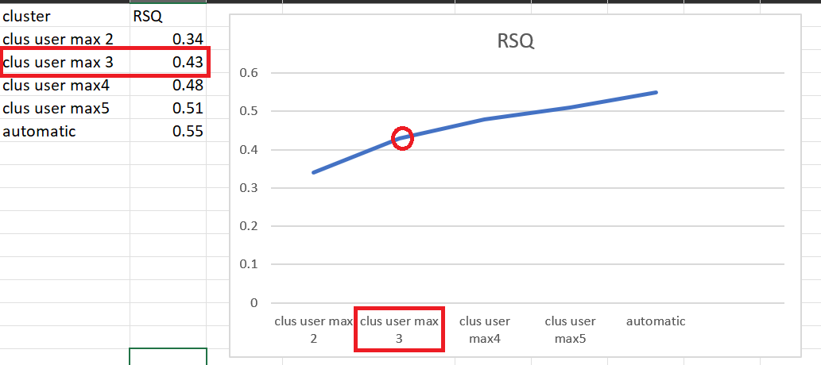
Input Means Plot: displays the normalized mean value for each variable
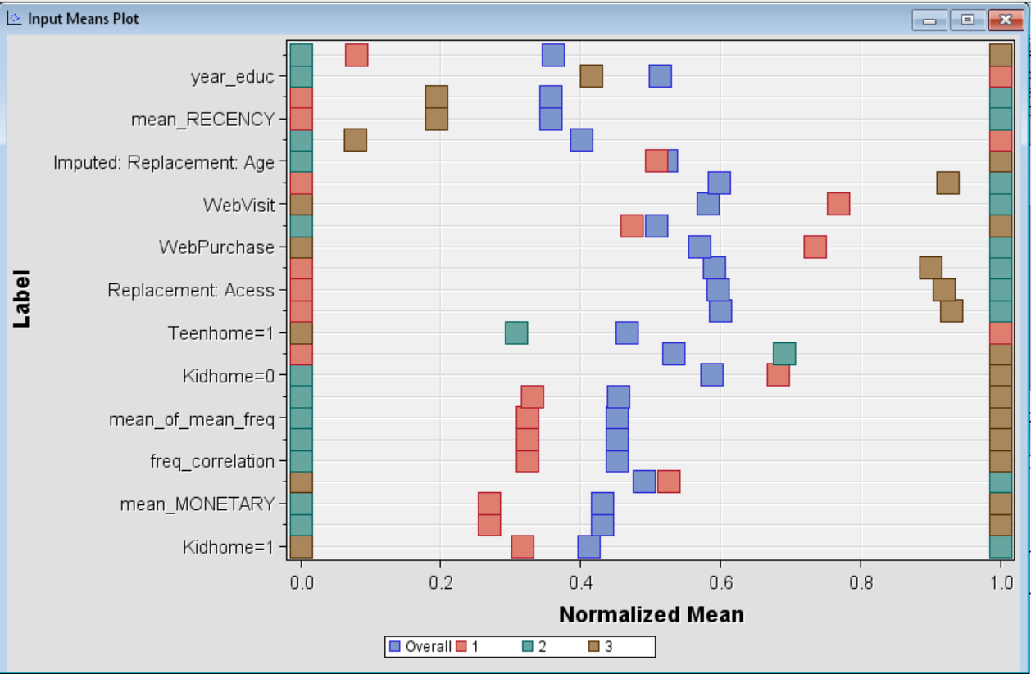

Segment profile
Red bar: distribution of the population (before targeting)
Blue bar: distribution of the segment (after targeting) 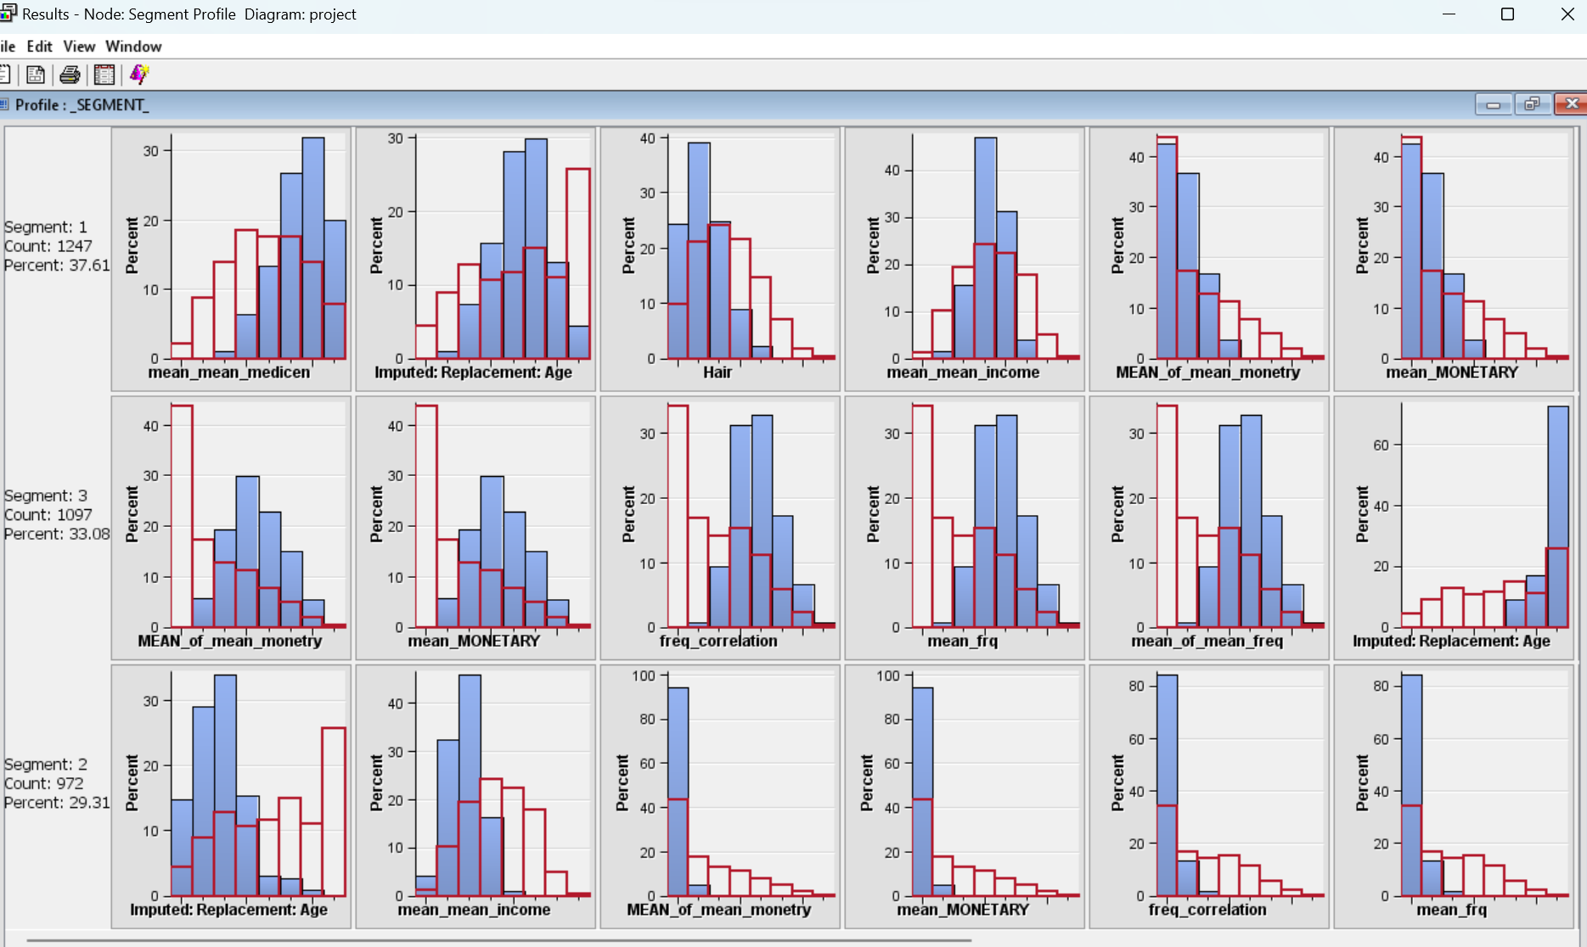

Then, after creating data partition we have set ‘’training’’ to 70 and validation to 30. Creation of multiplot is being accompanied with MONETORY variable that shows total sales to chosen person in the past 12 months.
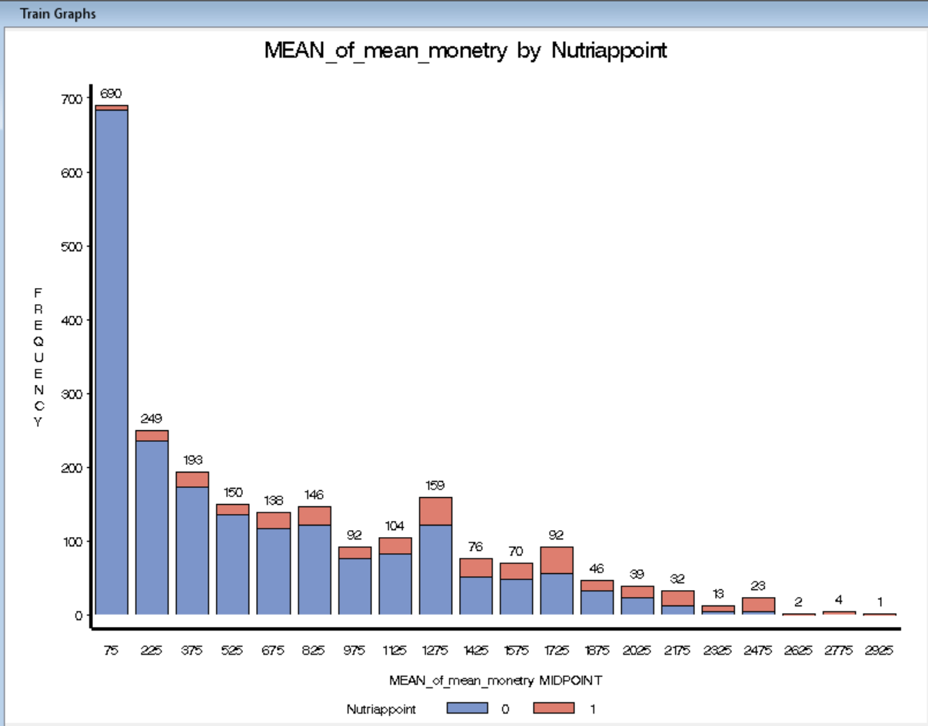

Stat explorer (and the graph below) shows all variables we created to target nutritiappoint.
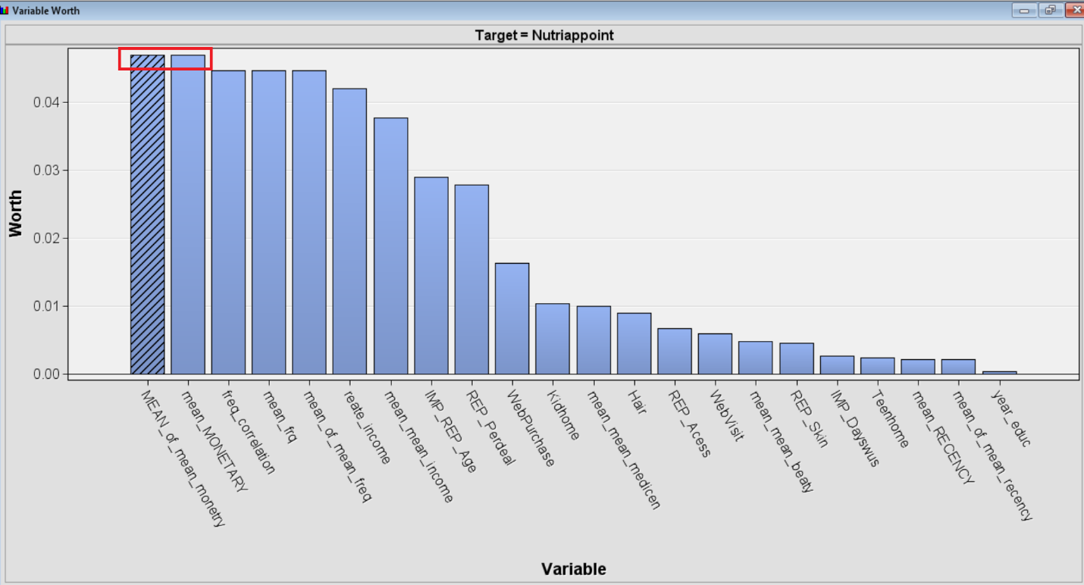
We have created 3 decision trees and 3 neural networks and after doing module comparison between them, best one for decision tree method was decision tree 3. For neural network the one with k set to 2 is best one and it is also best model of all models
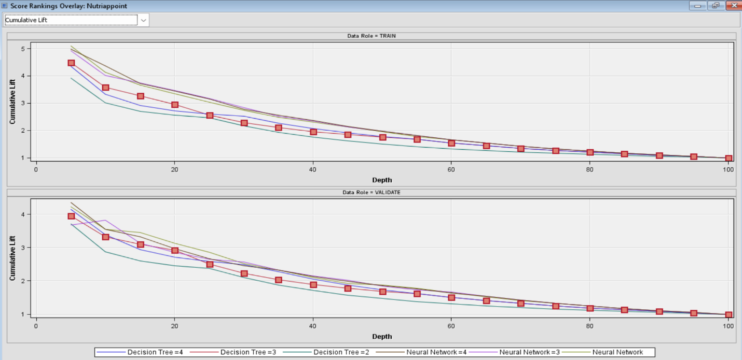

The graph below shows the results for decision tree 3
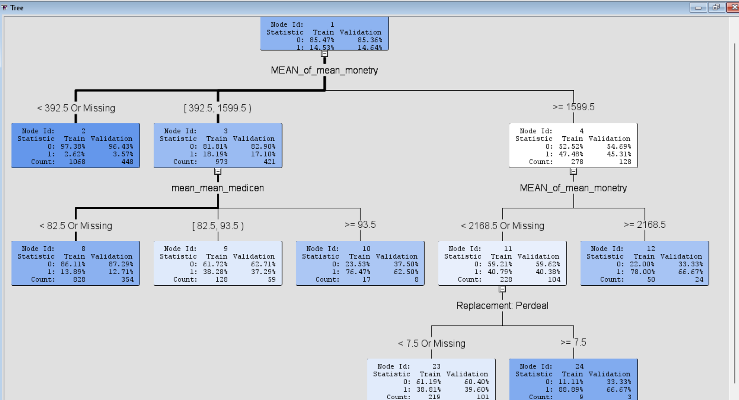

RESULTS AND CONCLUSIONS
We have put a lot of effort into this project and studied the client database. We have also created several modules and selected the best ones to present to you.
Following module compression between them, we created several decision trees and neural networks, with decision tree 3 emerging as the most effective. The best module for a neural network is the one with k set to 2, and it is also the best module among all modules. In addition, we showed you the multiplot result. Additionally, we removed any unnecessary modules and gave you the finest ones. In our opinion, you should rely on in order to conserve your business's funds and pique the interest of new clients

REFERENCES
*Steps for project and report – Ana Beatriz

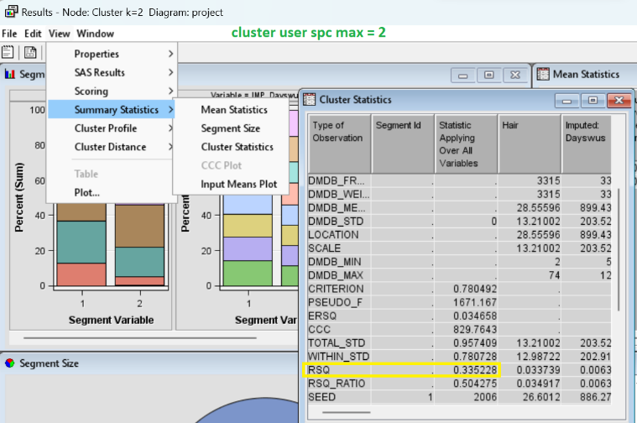
APPENDICES CONTAINING DETAILED INFORMATION
